*1.Title:*

《**What Happened in The Past Decade in China?》**

*2.Group Members:*

|  |  |
| --- | --- |
| Name | Student ID |
| Jiang Xinhou | 3035347990 |
| Yang Yonggui | 3035348633 |
| Yu Qingtian | 3035348918 |
| Wang Kaili | 3035348114 |

*3. Project objectives:*

1) Display various aspects(population, housing, technology, environment, culture, education etc.) of China in the past decade to help people look back the changes of the whole society vividly.

2) Analyze the connection among these aspects and the overall trend and get some valuable conclusion.

3) Find and design proper visualization diagrams and interaction ways to help people exactly under stand the data and data connections efficiently.

*4. Source and background of the data:*

Data source link: <http://data.stats.gov.cn/>

The data is selected from data.stats.gov.cn and we focus on the district data module, specifically, the province data by year and the main city data by year. We select some topics like population, GDP, architecture, tourism, construction and some of the like and download the data of different provinces or main cities about the above topics in the past ten years(we can only get the updated data from 2005 to 2014) to analyze and visualize.

*5.Questions about the data:*

None.

*6.Tasks:*

*7.Visualization tools and approaches:*

1) Use Tableau to display some fundamental data.

2) Program with D3.js to show some data that have some special design need for flexibility, which can not be accomplished with some visualization software.

8. Labor division:

|  |  |
| --- | --- |
| Name | Task |
| Jiang Xinhou | Analyze and visualize the data of tourism in china in the past ten years, the data mainly including the development of Chinese tourism(international and domestic)，tourists’ age/gender/nationality and tourism exchange revenue. The visualization will be finished mainly by programming with D3.js. After visualization, analyze the connection between tourism and other aspects like agriculture, environment, population, peoples’ income etc. |
| Yang Yonggui | 1. Visualize the data of agriculture in China in the past ten years. The data includes rural population, gross value of agricultural output, rural practitioners etc.  2.Try to find the way in which the different aspects of agriculture influence the agriculture economy.  3.Compare agriculture to other aspects like tourism, environment, population and people’s income etc. Find the connections between those and how it influence the Chinese economy. |
| Yu Qingtian |  |
| Wang Kaili | I will chose coastal ports and inland ports, showing the variation trend of berth length，the number of berth and other attributes in the past 10 years. |

**Preview some of the data under fundamental charts:**

1) .Population(ten thousand):

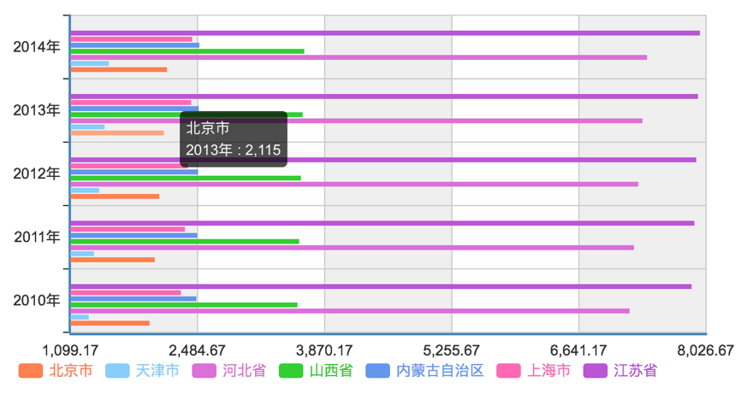

2).GDP(hundred million RMB)：

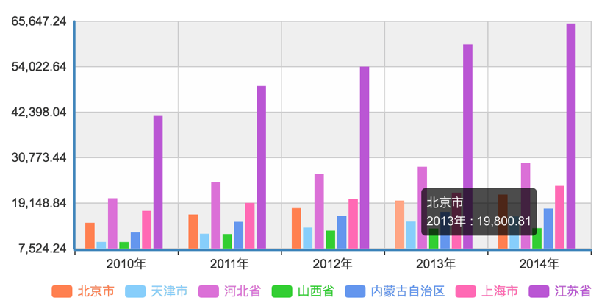

3). International tourism receipts(million dollars):



 